MODULE 3COSC002W.Y The Computer and Software Development:

Design and Test plan.

Part 1: design

Original design

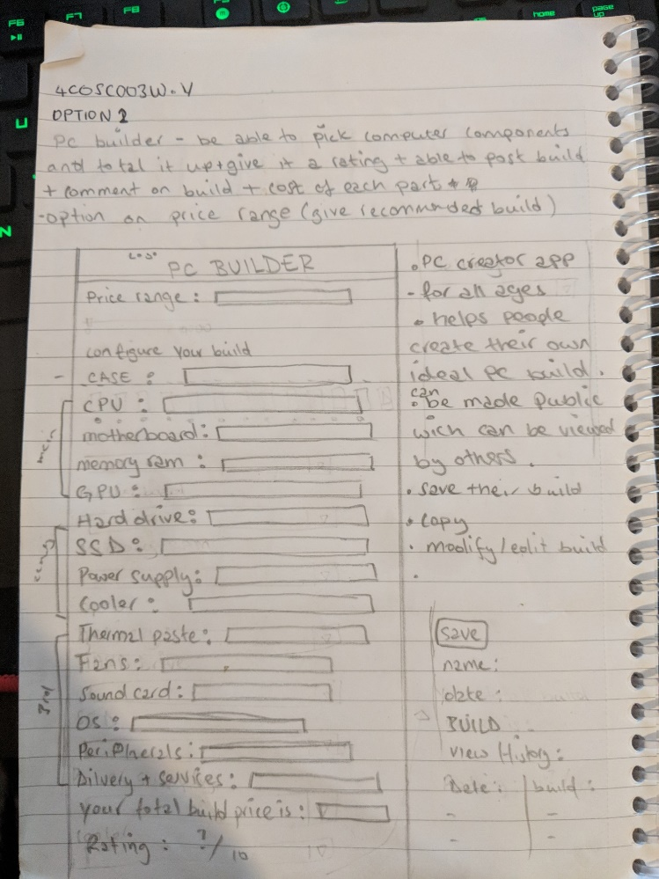

Updated design from March 26th 2018

Gui main window All builds

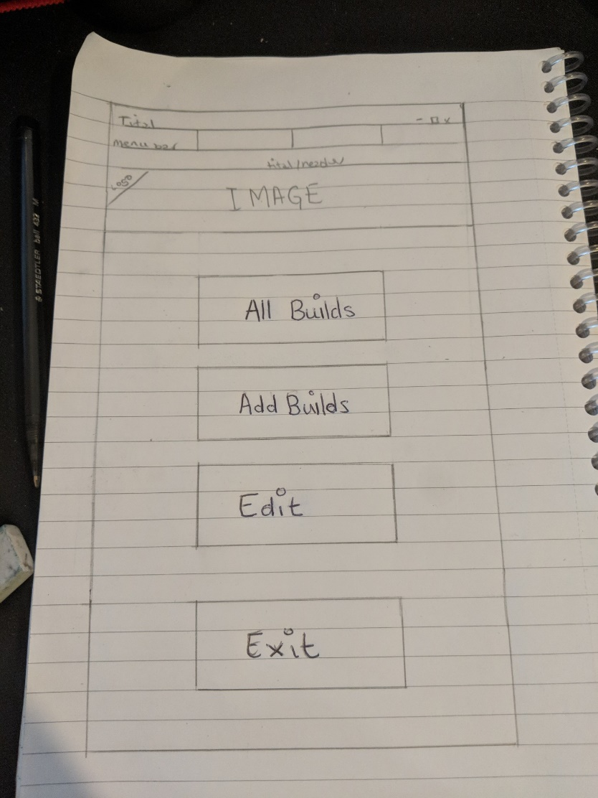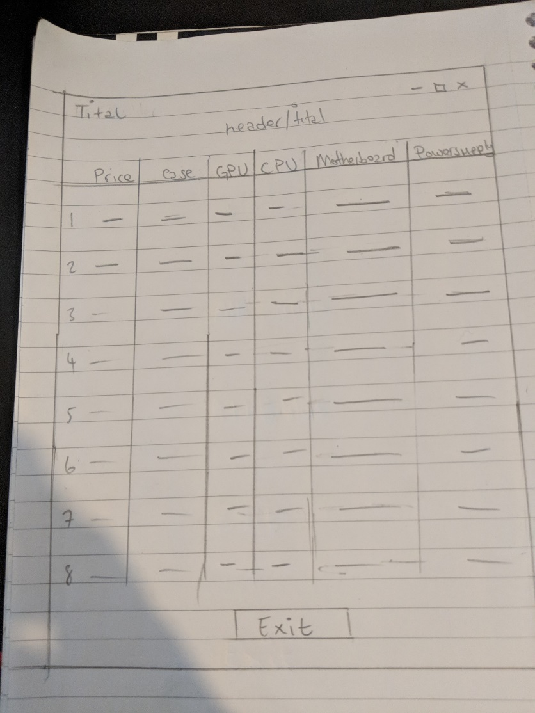

Add builds Edit

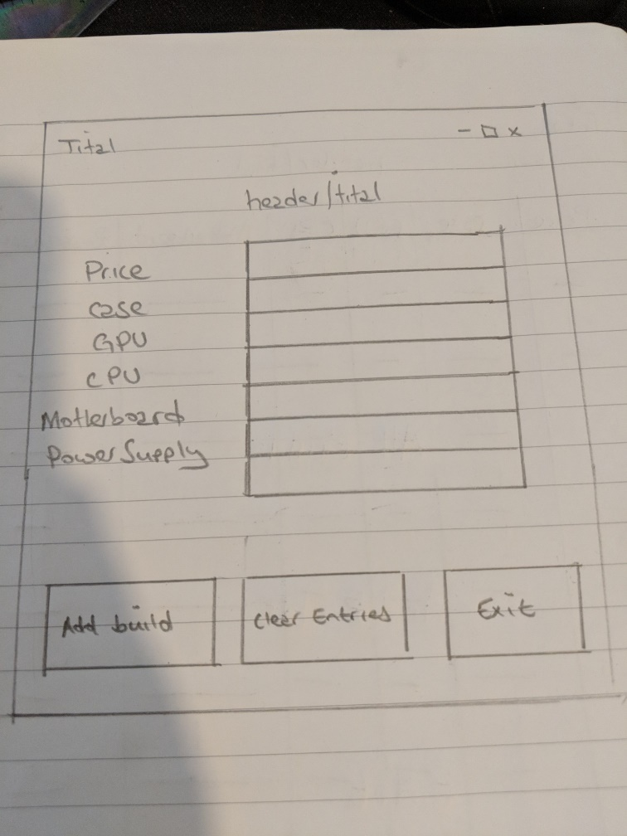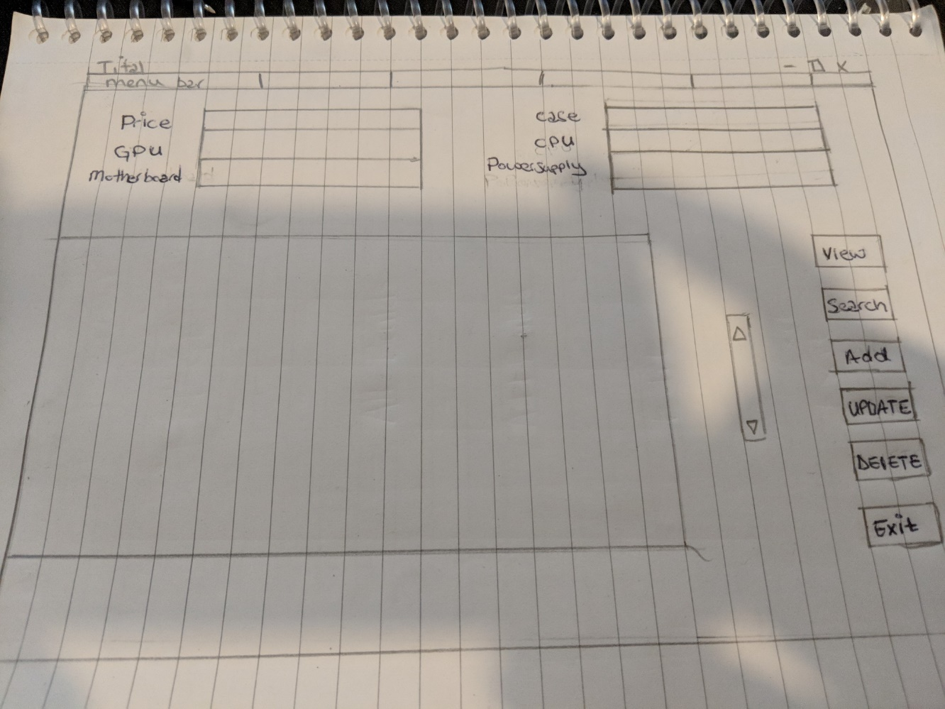

Part 2:Test plan

|  |  |  |  |  |
| --- | --- | --- | --- | --- |
| Coursework 2: Programming Assignment | Date:1/04/18 | Time:12:00 | Name: Abdi kadir Ismail |  |
| Test ref. | Description | Expected result | Actual result | Notes |
| 1 | All builds window test | After clicking a button, the list should appear from database | No list appeared but column is shown with the exit button | In order to fix this, I had to connect my list to the database |
| 2 | Edit window test | Should show all and in the right locations | Some of the stuff was overlapping due to use of the same row | In order to fix this I moved the buttons and list box by 2 rows |
| 3 | Menu tab on GUI home page test | Should appear with the rest | Are separated into two separated windows with the menu bar in a tk window | In order to resolve this I had to remove root = tk() and imbed the menu code before the rest of the code is executed. |
| 4 | All Builds, add build, Edit and Exit Buttons test | Should appear in a straight line in the middle | Ended up as small and on the left-hand side | In order to fix this I had to remove some commands and edit it so that it on the top rather than bottom and left side by changing changed grid to .pack. |
| 5 | Image(logo) on GUI home page test | Image should appear in this window under thee header and menu-tab but above the buttons | Image was not appearing as well as the buttons | This was due to conflicting code which had to be removed. |
| 6 | Edit window | Input and output of database should work properly | Input of edit window is using different database to the all builds and add build windows | So I had to remove one of the database and connect it to the same table and database file. |
| 7 | Database backend | Expected to make a simple database using sql on cmd | Database became faulty as table | This did not work so I made a python version. |